Chapter 4, Problem 54.

Find the Thèvenin equivalent between terminals a-b of the circuit in Fig. 4.120.

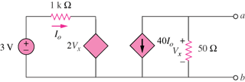
+

–

Figure 4.120
For Prob. 4.54.

